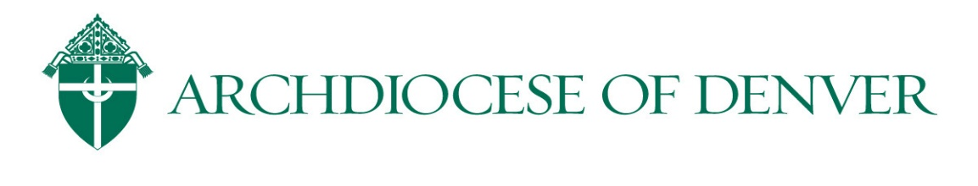
Here are the instructions for the online Safe Environment 5 Year Refresher Training in VIRTUS. Please allow 30-45 minutes to complete the online training

The current course for the Archdiocese of Denver’s Safe Environment refresher requirement is “Vulnerable Adults.” Per our Code of Conduct, all church workers (volunteers included) are mandated reporters of elder abuse as well as child abuse. This course educates the faithful about this requirement to protect the vulnerable of all ages and satisfies the Safe Environment training refresher requirement.

- You may receive an email notification from VIRTUS regarding the assignment of the online training module and may use those instructions to log into your account or use the instructions below:

- Go to www.virtus.org to log in as an “existing user”

User ID: [User ID can be found in “General” tab of user’s VIRTUS record]
Password: [Site Admin will have to replace existing password in user’s account and save changes to provide here]
(Please update your password in the “Update Your Account” link on the top right.)

- On the Home tab, click on the link indicating the online module assignment in the “Current Training” box.
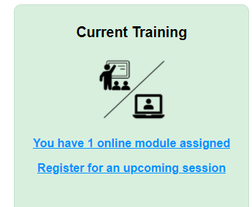
- Click on “Vulnerable Adults Training Module” under “Online Training Modules” to begin module in a separate pop up box.
- The refresher training consists of 5 videos with questions/scenarios. Note that if fast forward is used at any point, the training will not move forward and allow completion until the video is completely re-watched.

Completion of this module will be automatically recorded in your VIRTUS account and satisfies your AOD Safe Environment Training requirement for another 5 years.

***Your VIRTUS account also gives you access to a multitude of articles regarding child and youth safety through the “Training Bulletins” box on the Home tab.

