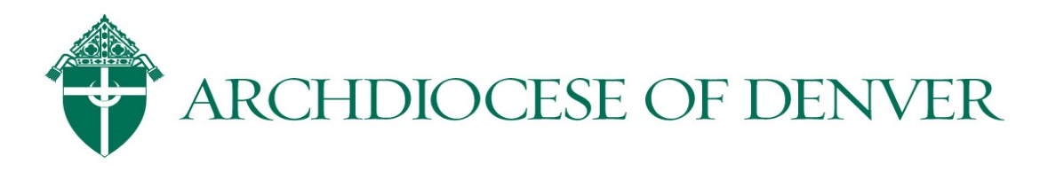
Safe Environment Program
Pastor Checklist
October 1, 2020

Adult Training
- All clergy, all religious, all employees and all volunteers working with children must have live Safe Environment Training (SET), a background check and read and sign the Code of Conduct.
- New employees and volunteers need to register through VIRTUS for a SET class at www.ArchDen.orgOfficesChild & Youth ProtectionFind a VIRTUS class. After they attend training, their certificate will be automatically recorded in the VIRTUS system by the facilitator. Classes are currently being offered in person and via webinar during COVID-19.
- All adults who have previously taken SET, will need to do online refresher training and have a new background check every 5 years. A new Code of Conduct signature is required only if the Code has been revised.
- All Clergy and Religious SET, refresher completion, background checks and Code of Conduct signatures are managed at the Chancery, not at the parish level.

Parish Safe Environment Coordinator (SEC)
- Verify that your SEC has completed the required administrative training with the Office of Child and Youth Protection for access and management of VIRTUS Online system for all employees and volunteers at your location.
- SEC’s will record background check and Code of Conduct signature dates and assign online refresher modules and provide the employees and volunteers with their log-in information and instructions for completing refresher training.
- The Employee and Volunteer Certification Form (Form B) is due to the Office of Child and Youth Protection on February 28th, every year. School employee and volunteer training reports are due to the Office of Catholic Schools June 30th, every year.
- VIRTUS Online is where individual adult compliance information is stored and easily recalled for completion of Form B and OCS reports.

Child and Youth Training
- Find Parent/Guardian Lessons Outlines at ArchDen.orgOfficesChild & Youth ProtectionVIRTUS Child & Youth Lesson Plans.
- Verify that your Director of Religious Education and school Principal have contacted the Office of Child and Youth Protection for access and management of VIRTUS Online. This is where they will access VIRTUS Empowering God’s Children™ downloadable curriculum. This is also where opt-out and parent-led forms are found.
- A reformatted, parent specific lesson plan is available this year as temporary solution due to COVID-19 and for home Catechesis programs.
- The Parish Safe Environment Certification Form (Form A) is due to the Office of Child and Youth Protection February 28th, every year.
- Archdiocesan schools also use the VIRTUS Empowering God’s Children™ program and those child and youth training verification reports are due January 31st to the Office of Catholic Schools.

