To receive credit for your class you must register with VIRTUS, indicate the class you attended and notify your facilitator upon completion of the account.

Facilitator Name:_______________________ Facilitator Contact:___________________________

Go to www.virtus.org  Click on First-Time Registrant.  Click on Begin the registration process.  Select the name Denver - Archdiocese from the pull-down menu. | 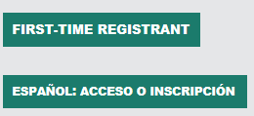  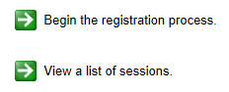
Create a User ID and Password you can easily remember.  Provide all the required information requested on the following screen.  (Note: Do not click the back button or your registration will be lost.) | 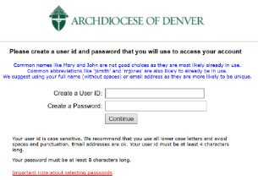  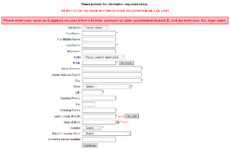
Select the PRIMARY location where you work or volunteer on the dropdown menu.  Select the role(s) that you serve within the Archdiocese of Denver.  Select YES if you need to add secondary/additional locations.  Select NO, if your list of locations is complete,. | 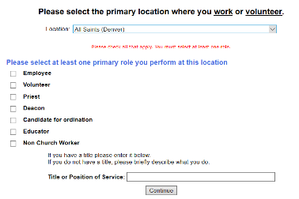
Please review or download the Archdiocese of Denver Code of Conduct.  To proceed, please Confirm by clicking on: “I hereby represent that I have downloaded, read, and understand this document.” and enter your full name and today’s date.  Please answer yes or no to the subsequent 4 questions. | 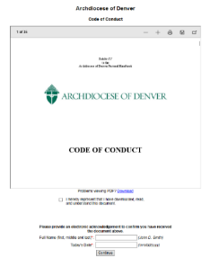
Please answer yes as to whether you have already attended a VIRTUS Protecting God’s Children Session

You will be presented with a drop down list of all instructor led VIRTUS sessions previously conducted in the Archdiocese of Denver. Choose the session you attended then click Continue.

Notify the facilitator of your completion. Once confirmed, you will receive an email from VIRTUS and can access the certificate by logging into your VIRTUS account.

If you have additional questions about the VIRTUS registration, please contact Alex.Kwan@archden.org

Thank you for completing the registration process!

