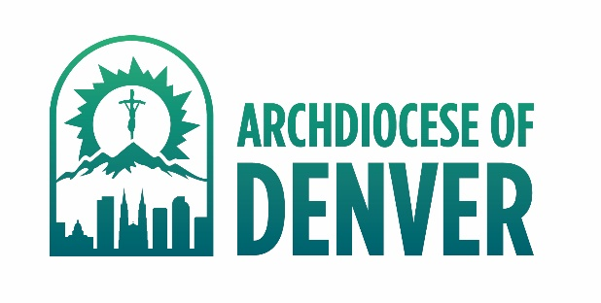

**5 Year Safe Environment Refresher Training**

As of July 2025, the standard online *refresher* safe environment course for the AOD is:

“**Healthy Boundaries for Adults: Boundary Development and Implementation™**

After the refresher is assigned by a parish or school administrator you will access it through your individual VIRTUS account.

**INSTRUCTIONS**

1. You may receive an email notification from VIRTUS regarding the assignment of the online training module and may use those instructions to log into your account or use the instructions below:
2. Go to [www.virtus.org](http://www.virtus.org) to log in as an “existing user”

User ID: [User ID can be found in “General” tab of user’s VIRTUS record]

Password: [Local Coordinator can reset a temporary password]  
(Please update your password in the “Update Your Account” link on the top right.)

1. On the Home tab, click on the link indicating the online module assignment in the “Current Training” box.

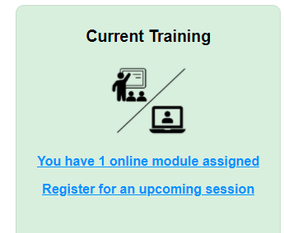

1. Click on “Healthy Boundaries Training Module” under “Online Training Modules” to begin module in a separate pop up box. The module consists of video presentation with accompanying questions.
2. Allow one hour to complete; it does not have to be completed in one sitting.

Completion of this module will be automatically recorded in your VIRTUS account and satisfies your AOD Safe Environment Training requirement for another 5 years.

Your VIRTUS account also gives you access to a multitude of articles regarding child and youth safety through the “Training Bulletins” box on the Home tab.